<https://prohousedemolitionsbrisbane.com/house-demolition-cost-brisbane/#:~:text=Breaking%20Down%20the%20Average%20Cost,back%20around%20%2440%20to%20%24150>.

<https://www.realestate.com.au/property/99-cornwall-st-annerley-qld-4103/> is an asbestos house

<https://apps.des.qld.gov.au/heritage-register/map/> heritage registry

<https://www.qld.gov.au/housing/public-community-housing/public-housing-tenants/looking-after-your-home/safety/asbestos#:~:text=How%20can%20I%20tell%20if,in%20this%20period%20contain%20asbestos>.

# Demolition Costs

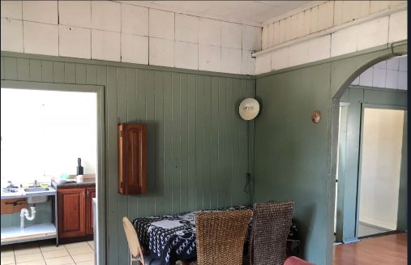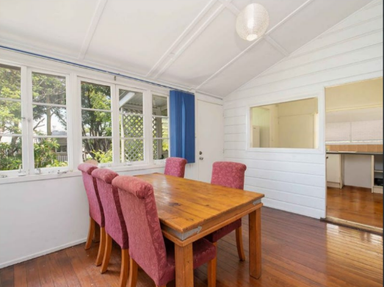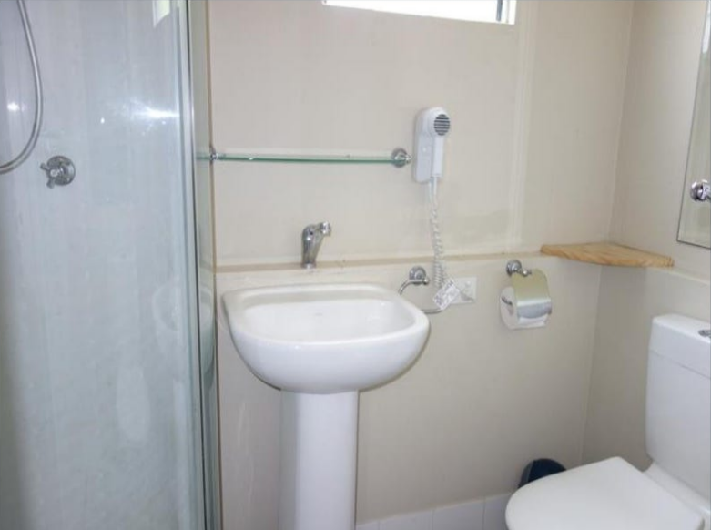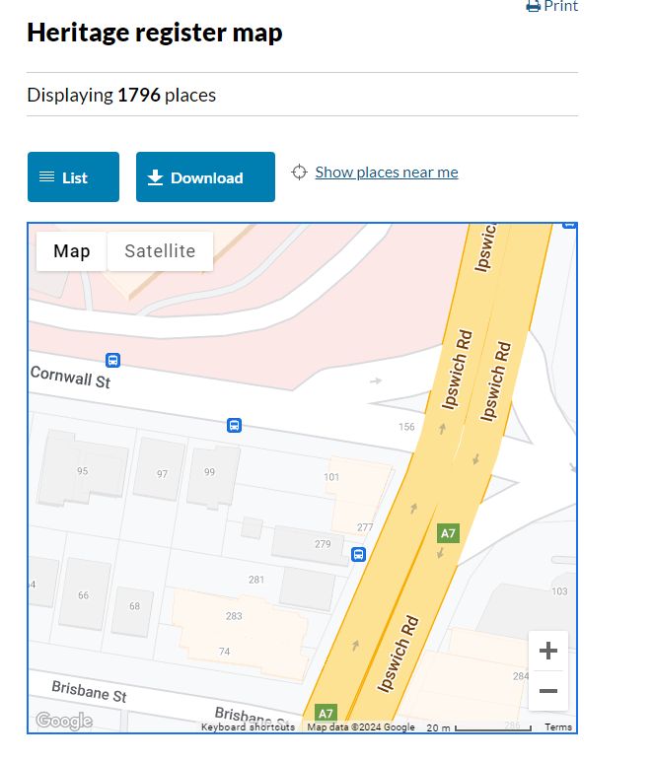

The Annerley development site necessitates the complete demolition of four buildings and an adjacent carpark prior to construction. While assuming the relevant development approvals, the certainty of the building's demolition was verified by referencing the relevant search codes in the heritage registry.

Through recent house sales observation, it was determined that dwellings on 97 Cornwell, 99 Cornwell, and 279 Ipswitch Road street contain asbestos floor and wall sheeting, which must be considered in the demolition costs. Removal and disposal of asbestos material can significantly increase demolition costs, with online quotes indicating additional costs of $40 per square meter. These costs include expenses for asbestos testing, removal clearance certificates, removal permits, and specialised waste management plans.

Additional removal costs for the carpark over property lines 1-RP37922, 2-RP37922, and 3-RP37922 were also factored into the final demolition costs, with costs per square meter provided by Rawlinsons.